Name: _______________________________________________
Foundation Unit 13 topic test
Date:
Time: 60 minutes
Total marks available: 51
Total marks achieved: ______

Questions
Q1.
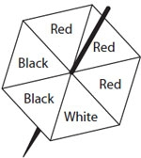
Here is a fair 6-sided spinner.
Jack will spin the spinner once.
The spinner will land on one of the colours.
Draw a circle around the word to best describe the probability of the following events.
(a) The spinner will land on White.
(1)
impossible | unlikely | even | likely | certain
(b) The spinner will land on Red.
(1)
impossible | unlikely | even | likely | certain
(c) The spinner will land on Pink.
(1)
impossible | unlikely | even | likely | certain

Here is a different fair 6-sided spinner.
Jack will spin this spinner once.
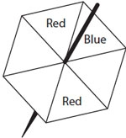
The spinner is more likely to land on Blue than to land on Red.
(d) Write the missing colours on the spinner.
(1)
(Total for Question is 4 marks)
Q2.
Here is a fair 4-sided spinner.
The spinner can land on blue or on red or on green.
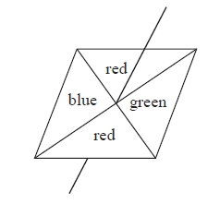
Lance spins the spinner once.
(a) On the probability scale, mark with a cross (×) the probability that the spinner will land on red.
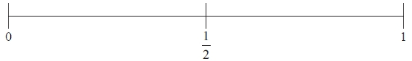
(1)
(b) On the probability scale, mark with a cross (×) the probability that the spinner will land on yellow.
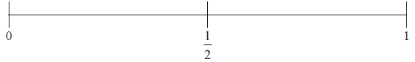
(1)
(c) On the probability scale, mark with a cross (×) the probability that the spinner will not land on green.
(1)
(Total for Question is 3 marks)

Q3.
There are some boys and girls in a classroom.
The probability of picking at random a boy is
What is the probability of picking a girl?
...........................................................
(Total for question = 1 mark)

Q4.
Jessica goes to an activity centre.
She can choose to do one of the three morning activities and one of the three afternoon activities.
Morning activities | Afternoon activities
Cookery (C) Painting (P) Football (F) | Hockey (H) Acting (A) Swimming (S)
List all the possible combinations of activities she can choose to do.
The first combination has been done for you.

..............................................................................................................................................
..............................................................................................................................................
(Total for Question is 2 marks)

Q5.
Liam throws a fair coin once.
(a) On the probability scale below, mark with a cross (×) the probability that he gets a head.
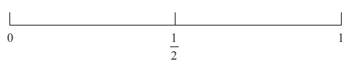
(1)
Ann rolls a fair dice once.
(b) On the probability scale below, mark with a cross (×) the probability that she gets a 7
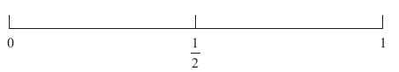
(1)
Fred throws a fair coin and rolls a fair dice.
(c) (i) List all the possible combinations.
The first one has been done for you.

..............................................................................................................................................
..............................................................................................................................................
..............................................................................................................................................
(ii) Write down the probability that Fred gets a head and an even number.

..............................................................................................................................................
(4)
(Total for Question is 6 marks)

Q6.
Tim plays a game.
He can win the game or he can lose the game or he can draw the game.
The probability that Tim will win the game is 0.25
The probability that Tim will lose the game is x.
(a) Give an expression, in terms of x, for the probability that he will draw the game.
...........................................................
(2)
Tim plays the game 240 times.
(b) Work out an estimate for the number of times he will win the game.
...........................................................
(2)

(Total for Question is 4 marks)

Q7.
There are 72 guests staying in a hotel.
They are French or German or Spanish.
The two-way table shows some information about the guests.
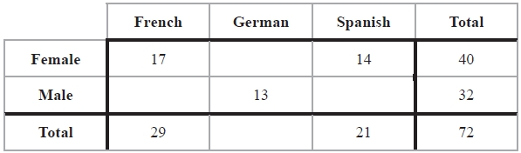
(a) Complete the two-way table.
(2)
One of these guests is picked at random.
(b) Write down the probability that the guest is female.
...........................................................
(1)
One of the male guests is picked at random.
(c) Write down the probability that this male guest is German.
...........................................................
(1)
(Total for Question is 4 marks)

Q8.
There are only blue counters, green counters, red counters and yellow counters in a bag.
George is going to take at random a counter from the bag.
The table shows each of the probabilities that George will take a blue counter or a green
counter or a yellow counter.
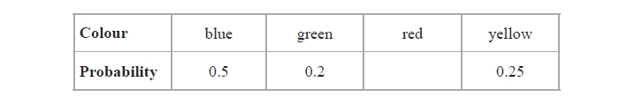
(a) Work out the probability that George will take a red counter.
...........................................................
(1)
There are 120 counters in the bag.
(b) Work out the number of green counters in the bag.
...........................................................
(2)

(Total for question = 3 marks)

Q9.
There are only red counters, blue counters, green counters and yellow counters in a bag.
The table shows the probabilities of picking at random a red counter and picking at random a yellow counter.
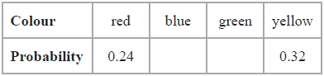
The probability of picking a blue counter is the same as the probability of picking a green counter.
Complete the table.

(Total for question is 2 marks)

Q10.
Denzil has a 4-sided spinner.
The sides of the spinner are numbered 1, 2, 3 and 4
The spinner is biased.
The table shows each of the probabilities that the spinner will land on 1, on 3 and on 4
The probability that the spinner will land on 3 is x.
Number | 1 | 2 | 3 | 4
Probability | 0.3 |  | x | 0.1
(a) Find an expression, in terms of x, for the probability that the spinner will land on 2 Give your answer in its simplest form.

..............................................................................................................................................
(2)
Denzil spins the spinner 300 times.
(b) Write down an expression, in terms of x, for the number of times the spinner is likely to land on 3

. . . . . . . . . . . . . . . . . . . . . . . . . . . . . .
(1)
(Total for Question is 3 marks)

Q11.
Here is a probability tree diagram.
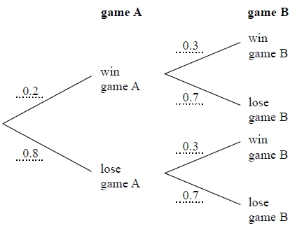
Work out the probability of winning both games.
...........................................................
(Total for question = 2 marks)

Q12.
Wendy goes to a fun fair.
She has one go at Hoopla.
She has one go on the Coconut shy.
The probability that she wins at Hoopla is 0.4
The probability that she wins on the Coconut shy is 0.3

(a) Complete the probability tree diagram.
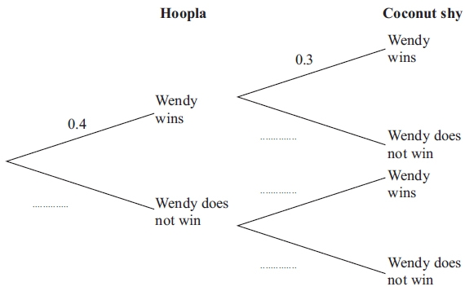
(2)
(b) Work out the probability that Wendy wins at Hoopla and also wins on the Coconut shy.

..............................................................................................................................................
(2)
(Total for Question is 4 marks)

Q13.
100 students had some homework.
42 of these students are boys.
8 of the 100 students did not do their homework.
53 of the girls did do their homework.
(a) Use this information to complete the frequency tree.
(3)
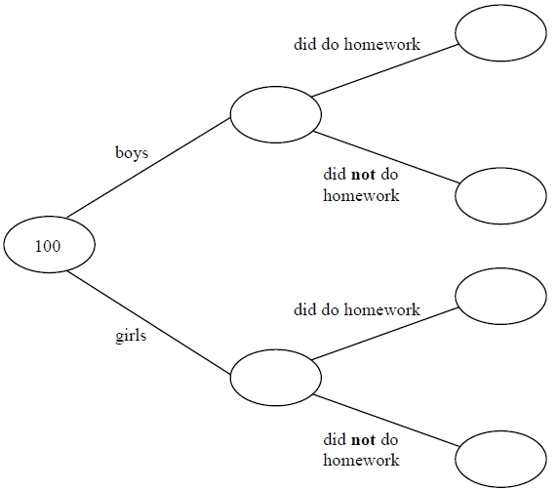
One of the girls is chosen at random.
(b) Work out the probability that this girl did not do her homework.
...........................................................
(2)
(Total for question = 5 marks)
Q14.
Here is a Venn diagram.
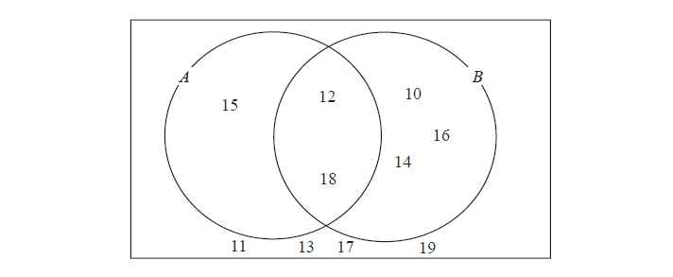
(a) Write down the numbers that are in set
(i) A ∪ B
...........................................................
(ii) A ∩ B
...........................................................
(2)
One of the numbers in the diagram is chosen at random.
(b) Find the probability that the number is in set A'
...........................................................
(2)

(Total for question = 4 marks)

Q15.
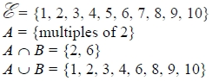
Draw a Venn diagram for this information.

(Total for question is 4 marks)

Examiner's Report
Q1.
This question was well answered except for part (b). In part (b) the majority of candidates indicated likely as the answer instead of even. In part (d) most candidates scored well however a common mistake was to add two blues and then one red, making the probability even.

Q2.
This question was not as well answered as is usually the case. In part (b) there were many guesses, with crosses commonly placed at ¹⁄₄ or ³⁄₄. In part (c) a significant number of students failed to mention the "not" and placed their cross at ¹⁄₄ instead of ³⁄₄.

Q3.
No Examiner's Report available for this question

Q4.
The vast majority of candidates had some idea about listing combinations and most wrote down all nine possible combinations. Most of the lists were systematic and written in a logical order. Some candidates wrote the nine correct combinations but also listed some repeats. A few candidates listed only (P, A) and (F, S).

Q5.
Part (a) was accessible to all with most candidates scoring the mark. Part (b) was also accessible to most with the majority scoring the mark.
In part (c)(i), most candidates were able to list the outcomes correctly and gained the two marks here with very few mistakes. The most common error was to go past 6 as a score on the dice or to use three different letters as well as numbers.
For part (c)(ii), many candidates failed to see the link with their combinations and gave the answer as a half, or equivalent. One or two attempted to calculate the answer using other methods such as a tree diagram. An answer of ³⁄₆ was a common response, as was ³⁄₁₁ , when the candidate did not include the given combination. Only occasionally was the answer given as a ratio or in words.

Q6.
Only a handful of candidates scored any marks in part (a) with x − 0.25 being a common incorrect response for those making any algebraic attempt. By contrast, part (b) was well answered with many correct responses. A few candidates reached 80 as they divided 240 by 3 (win, lose, draw) and a few wrote ¼ × 240 or 240 ÷ 4 but then failed to get to 60.

Q7.
Parts (a) and (b) were well answered. There are few instances these days of students writing probabilities inappropriately, i.e. using ratios or odds. Decimals were accepted for probabilities as long as these were written to at least 2 d.p. The most common error in part (c) was giving the denominator as 72 instead of 32.

Q8.
No Examiner's Report available for this question

Q9.
No Examiner's Report available for this question

Q10.
Performance on this question was very poor with 95% of candidates scoring no marks at all. In part (a) there was a common assumption was that P(2) and P(3) were equal leading to evaluation of 0.3 for each. Where candidates did use 1 as the sum of the probabilities, they were unable to provide a correct algebraic expression.
Candidates had marginally more success with part (b) but the correct expression was very rarely seen and more often a numerical value calculated in part (a) was used.

Q11.
No Examiner's Report available for this question

Q12.
In part (a) the vast majority of candidates were able to get the value 0.6 correct but there was less success with the second set of branches. Many candidates had the correct values for the lower set of the right hand branches but had these values transposed. As usual, part (b) proved more problematic. The correct method of 0.3 × 0.4 was frequently followed by the incorrect answer of 1.2 with candidates seemingly having no qualms of giving a probability greater than 1 as their final answer. However, 0.3 + 0.4 was a very commonly seen incorrect method.

Q13.
No Examiner's Report available for this question

Q14.
No Examiner's Report available for this question

Q15.
No Examiner's Report available for this question

Mark Scheme
Q1.
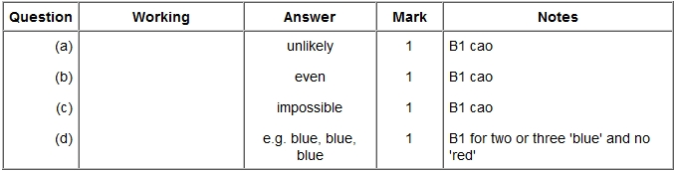

Q2.
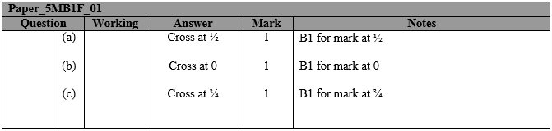

Q3.
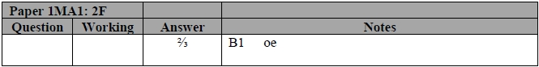

Q4.
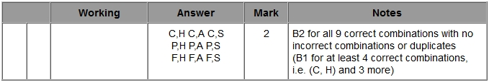

Q5.
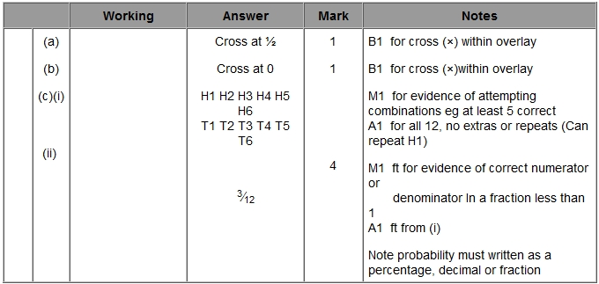

Q6.
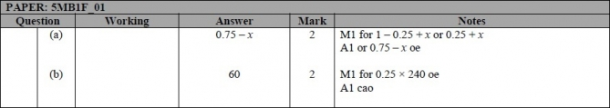

Q7.
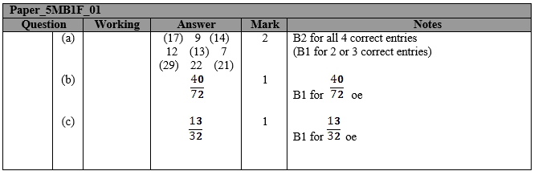

Q8.
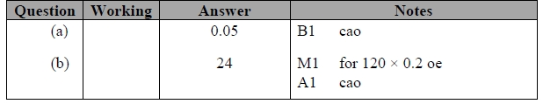

Q9.
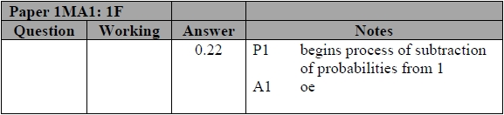

Q10.
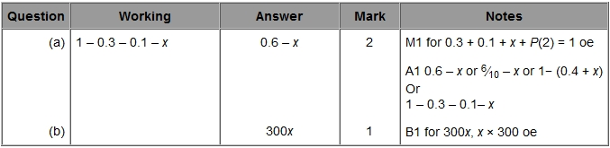

Q11.
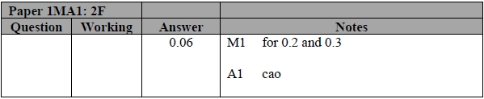

Q12.
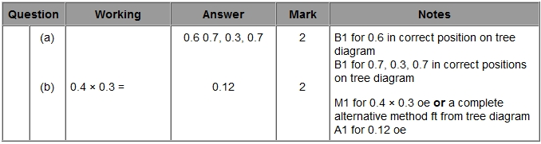

Q13.
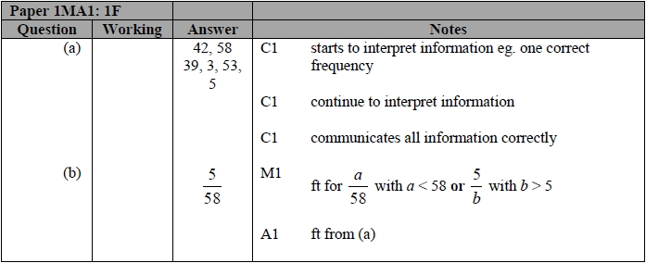

Q14.
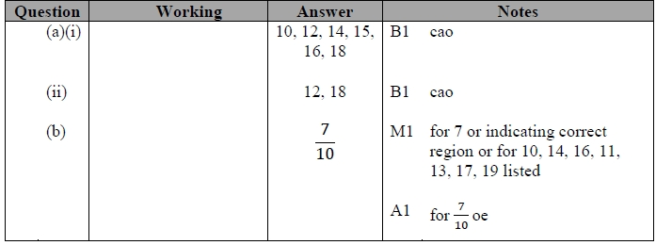

Q15.
